**Experiment 5**

**AIM - Implement Genetics / Hill Climbing in Python.**

**Code – Genetics**

import numpy as np

population_size = 6

gene_length = 4

num_generations = 100

crossover_rate = 0.5

mutation_rate = 0.1

num_parents = int(population_size / 2)

print("Niyati's Code for Genetics algorithm")

def initialize_population(size, gene_length):

return np.random.randint(0, 31, (size, gene_length))

def calculate_fitness(chromosome):

objective_value = abs(sum([chromosome[i] * (i+1) for i in range(len(chromosome))]) - 30)

fitness_value = 1 / (1 + objective_value) # Modified to match the provided logic

return fitness_value

def select_parents(population, fitness, num_parents):

fitness_sum = np.sum(fitness)

probability = fitness / fitness_sum

chosen = set() # Set to keep track of which individuals have been chosen

parents = np.empty((num_parents, population.shape[1]))

for parent_num in range(num_parents):

rand = np.random.rand()

cumulative_probability = 0.0

for i in range(len(probability)):

if i not in chosen:

cumulative_probability += probability[i]

if rand <= cumulative_probability:

parents[parent_num, :] = population[i, :]

chosen.add(i) # Mark this individual as chosen

break

return parents

def crossover(parents, offspring_size, crossover_rate):

offspring = np.empty(offspring_size)

for k in range(offspring_size[0]):

if np.random.rand() < crossover_rate:

parent1_idx = k % parents.shape[0]

parent2_idx = (k+1) % parents.shape[0]

crossover_point = np.random.randint(1, offspring_size[1])

offspring[k, 0:crossover_point] = parents[parent1_idx, 0:crossover_point]

offspring[k, crossover_point:] = parents[parent2_idx, crossover_point:]

return offspring

def mutate(offspring_crossover, mutation_rate):

for idx in range(offspring_crossover.shape[0]):

for gene in range(offspring_crossover.shape[1]):

if np.random.rand() < mutation_rate:

offspring_crossover[idx, gene] = np.random.randint(0, 31)

return offspring_crossover

population = initialize_population(population_size, gene_length)

print("Initial Population:\n", population)

for generation in range(num_generations):

fitness = np.array([calculate_fitness(individual) for individual in population])

print(f"\nGeneration {generation} Fitness:\n", fitness)

parents = select_parents(population, fitness, num_parents)

print("Selected Parents:\n", parents)

offspring_crossover = crossover(parents, (population_size - num_parents, gene_length), crossover_rate)

print("Crossover Offspring:\n", offspring_crossover)

offspring_mutation = mutate(offspring_crossover, mutation_rate)

print("Mutated Offspring:\n", offspring_mutation)

population[:num_parents, :] = parents

population[num_parents:, :] = offspring_mutation

break

def genetic_algorithm(population, population_size, gene_length, num_generations, crossover_rate, mutation_rate, num_parents):

for generation in range(num_generations):

fitness = np.array([calculate_fitness(individual) for individual in population])

parents = select_parents(population, fitness, num_parents)

offspring_crossover = crossover(parents, (population_size - num_parents, gene_length), crossover_rate)

offspring_mutation = mutate(offspring_crossover, mutation_rate)

population[:num_parents, :] = parents

population[num_parents:, :] = offspring_mutation

final_fitness = np.array([calculate_fitness(individual) for individual in population])

best_index = np.argmax(final_fitness) # Use argmax because we are using inverted fitness values

best_solution = population[best_index]

print("\nFinal Best Solution:\n", best_solution)

print("With Fitness Score:", final_fitness[best_index])

genetic_algorithm(population, population_size, gene_length, num_generations, crossover_rate, mutation_rate,num_parents)

**Output –**

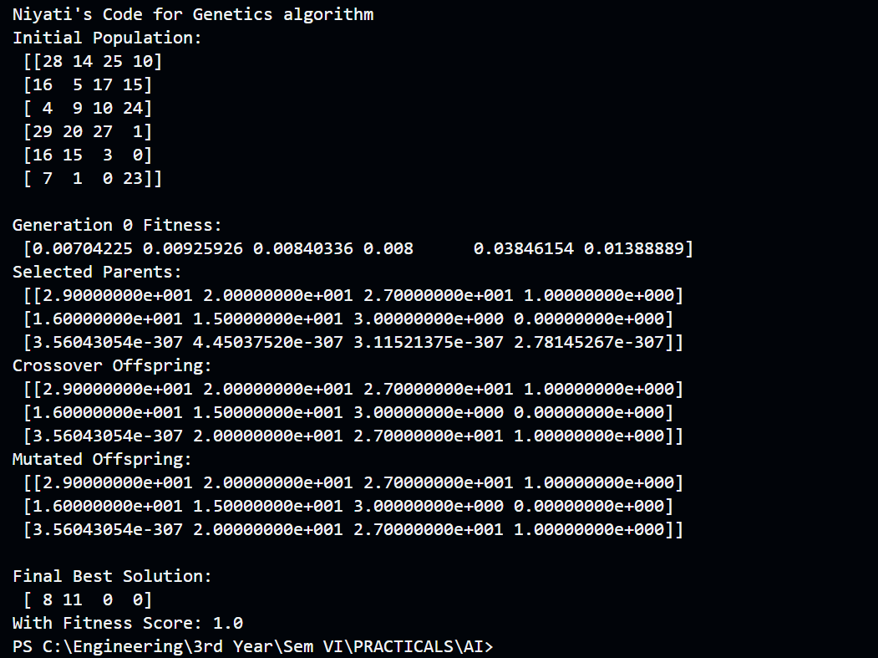

**Code – Hill Climbing**

import random

# Objective function to be maximized

def objective_function(x):

return -x ** 2

# Generate initial solution randomly

def generate_initial_solution():

return random.randint(-100, 100)

# Generate neighbour solutions

def generate_neighbours(solution):

neighbours = []

for delta in [-1, 1]:

neighbours.append(solution + delta)

return neighbours

# Get highest quality neighbour of current solution

def get_best_neighbour(neighbours):

best_neighbour = neighbours[0]

best_quality = objective_function(best_neighbour)

for neighbour in neighbours[1:]:

neighbour_quality = objective_function(neighbour)

if neighbour_quality > best_quality:

best_quality = neighbour_quality

best_neighbour = neighbour

return best_neighbour

# Hill climbing algorithm

def hill_climbing():

current_solution = generate_initial_solution()

# print("Initial Solution: ", current_solution)

while True:

neighbours = generate_neighbours(current_solution)

best_neighbour = get_best_neighbour(neighbours)

if objective_function(best_neighbour) <= objective_function(current_solution):

return current_solution

current_solution = best_neighbour

best_solution = hill_climbing()

print("Niyati's Code for Hill Climbing")

print("Best solution found:", best_solution)

print("Objective function value:", objective_function(best_solution))

**Output –**

